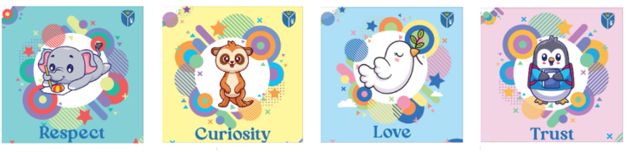

PSHE

Vocabulary Progression

.

Overview - Vocabulary progression
My healthy self
Year 1 | Year 2 | Year 3 | Year 4 | Year 5 | Year 6
anger  body clues  disgust  emotions  face clues  fear  feelings  happiness  relax  sadness  surprise  trust  trusted adult | active  exercise  five-a-day  healthy  habits | health  mental health  mind  mood  negative (feelings)  physical health  positive (feelings)  respect  routine  support  trust team | balanced diet  fixed mindset  growth mindset  hydrated/dehydrated  hygiene  mindset  nutrients  resilience | cope  light (activity)  moderate (activity)  regulate  response  vigorous (activity)  wellbeing | calories  (tooth) decay  dental hygiene  flossing  long-term  persistence  setback  short-term
*Words on this page are classified as Tier 2 words unless stated otherwise.
Connecting with others
Year 1 | Year 2 | Year 3 | Year 4 | Year 5 | Year 6
fair / unfair  friendly  lonely  polite  safe  share  strengths  trust  trusted adult | belong  bullying  calm  carer  family | behaviour  falling out  friendship  relationship  respect  self-respect | assertive  compromise  disrespect  manners | civil partnership  commitment  conflict  influence  marriage | bystander  discrimination  empathy  self-esteem  stereotypes  upstander
*Words on this page are classified as Tier 2 words unless stated otherwise.
The online world
Year 1 | Year 2 | Year 3 | Year 4 | Year 5 | Year 6
online  polite  safe  screen time  trusted adult | permission  personal information  private information  sharing | anonymous  block  communicate  report  respect  respectful  screenshot | content  in/accurate  mislead  reliable  search engine | advert  influence  scam  targeted | Coming soon!
*Words on this page are classified as Tier 2 words unless stated otherwise.
Citizenship
Year 1 | Year 2 | Year 3/4 | Year 5 | Year 6
Coming soon! | Coming soon! | budget  business  environment  human rights  local council  responsibilities  respect  career  job  training  gender  satisfaction  bank  value | Coming soon! | Coming soon!
*Words on this page are classified as Tier 2 words unless stated otherwise.
Staying safe
Year 1 | Year 2 | Year 4 | Year 6
999  body clues  comfortable  danger  emergency  harm  road safety  rule  safe  trusted adult  uncomfortable  unsafe | penis  permission  private parts  testicles  vagina  vulva | alcohol  boundaries  cigarettes  current  hazard  illegal  inappropriate  legal  operator  personal space  pressure  risk  road crossing  tide  vapes | addictive  air ambulance  cautious  coastguard  consent  criminal offence  drugs  emergency services  emotional  mountain rescue  peer pressure  physical  public transport  search-and-rescue  substance  threat  violence
*Words on this page are classified as Tier 2 words unless stated otherwise.
Health protection
Year 1 | Year 3
999  dentist  doctor  emergency  first aid  germs  illness  injury  medicine  prevent  protect  serious  spread  unwell  urgent | allergy  asthma  defence  disease  immune  infection  pressure  spf  sunburn  sunstroke  symptom  vaccine
*Words on this page are classified as Tier 2 words unless stated otherwise.
Further first aid (optional)
Year 6
Coming October 2026!
*Words on this page are classified as Tier 2 words unless stated otherwise.
Growing up
Year 2 | Year 4 | Year 5
change  grow  nipples  penis  private parts  scrotum  testicles  vagina  vulva | boundaries  breasts  period  physical changes  puberty | egg  erection  genitals  hormones  influence  menstrual cup  period pad  period pants  self-conscious  sensitive  tampon  wet dreams  womb/uterus
*Words on this page are classified as Tier 2 words unless stated otherwise.
Sex education (Optional)
Year 6
conception
consent
ovary
pregnant
sexual intercourse
sperm
*Words on this page are classified as Tier 2 words unless stated otherwise.

