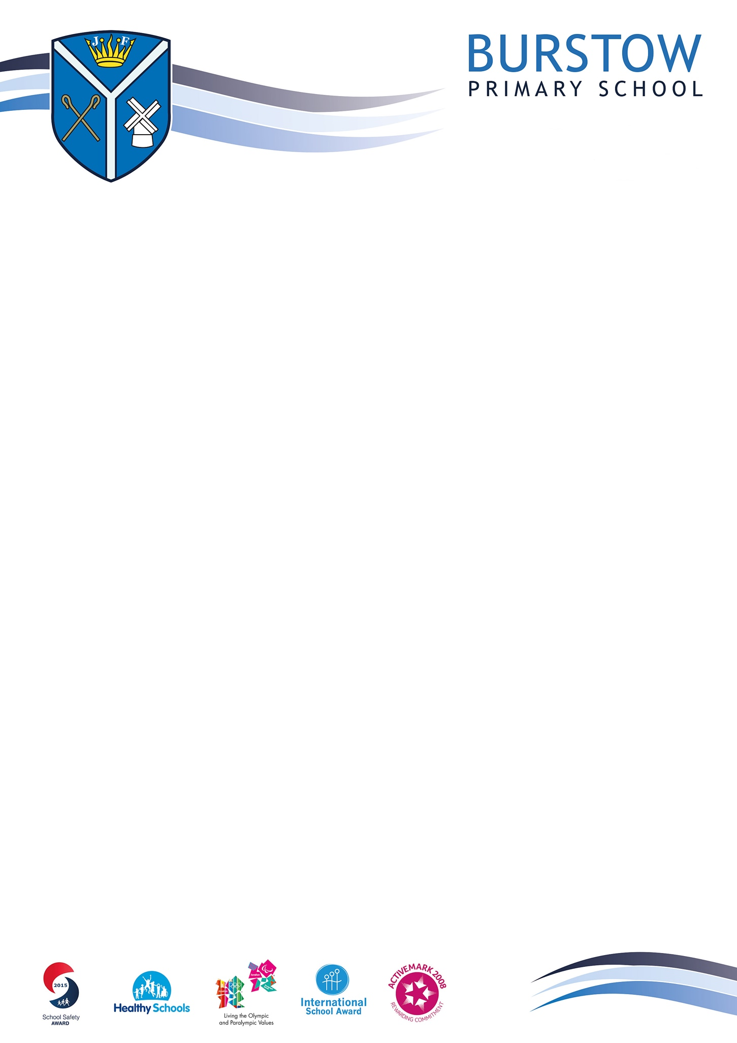

PARENT/CARER AND VISITOR

CODE OF CONDUCT

Review Date: September 2027
Published: September 2026


Code of Conduct for Parents, Carers and Visitors

At Burstow Primary School, we are proud and fortunate to have a very dedicated and supportive school community. At our school, the staff, governors, parents and carers all recognise that the education of our children is a partnership between us.

As a partnership, we appreciate the importance of good working relationships and the value of these relationships to equip our children with the necessary skills for their education. We welcome and encourage parents and carers to participate fully in the life of our school.

Our Core Values were designed to be community values upheld by children and adults alike. We expect our school community to respect our school’s Core Values by setting a good example through their own behaviour, both on the school premises and when accompanying classes on school visits.

In addition, we also expect our parents, carers and visitors to keep our children safe by adhering to the school’s requests to park safely outside the school gates during morning and afternoon collections.

This code of conduct outlines expectations around the conduct of all parents, carers and visitors connected to our school, ensuring we work together for the best interests of all our children.

We are committed to resolving difficulties in a constructive manner, through an open and positive dialogue. Where issues or misunderstandings arise, please contact your child’s teacher, phase leader or the Headteacher, who will meet with and discuss the issue and hopefully resolve it. Where issues remain unresolved, please follow the school’s complaints procedure. This is available on the school website or a copy can be requested from the school office.

This code of conduct is not an exhaustive list. Instead it aims to clarify the types of behaviour that are acceptable and not acceptable and seeks parental agreement to these expectations.

Guidance

We ask parents, carers and visitors to show respect and consideration for our diverse families and communities by:

- Promoting and demonstrating the school’s four Core Values: Trust, Love, Respect and Curiosity
- Supporting the school ethos by setting a good example both on and off the school premises.
- Being conscious of other parents, carers and children when talking on and off the school premises so as not to offend or intimidate in any way.
- Approaching the teacher, not the child or their parent, if an issue has arisen during the school day.
- Speaking to a class teacher or member of Senior Leadership if you have any concerns about the conduct of members of our community.
- Allowing plenty of time before school so that children arrive ready for a punctual start of the school day.
- Respecting the school environment, including keeping the school tidy and not littering.
- Dismounting bicycles and scooters at the school gate and walking the scooter or bicycle into the grounds to park at the bike shed.
- Not bringing animals onto the school premises for health and safety reasons, unless for educational purposes with prior permission of the school or if you have a registered assistance dog.
- Ensuring children are supervised in the playground before and after school hours.

The following are examples of behaviours that are not acceptable.

- Disruptive behaviour which interferes or threatens to interfere with any of the school’s normal operations or activities anywhere on the school premises or on school trips.
- Any inappropriate behaviour on the school premises or on school trips.
- Using loud or offensive language or displaying temper.
- Threatening in any way, a member of staff, visitor, parent/carer or child.
- Damaging or destroying school property.
- Sending abusive or threatening emails or text/voicemail/phone messages or other written communications (including social media) to anyone within the Trust or school community.
- The use of physical, verbal or written aggression towards an adult or child. This includes physical punishment of your own child on school premises.
- Language of a prejudicial nature including, but not limited to, homophobia, racism, nationalism & negative religious comments.
- Chastising someone else’s child because of their actions towards your own child.
- Smoking, vaping, taking illegal drugs or consuming alcohol on school premises or being under the influence of drugs or alcohol on the school premises. (Alcohol may only be consumed during authorised licenced events).

Use of Social Media

Most people take part in online activities and social media. It’s fun, interesting and keeps us connected.

FOBS has a Facebook page which allows parents to receive and respond to messages about school events. Most year groups have their own closed groups to enable parents to communicate. We encourage you to freely and positively participate if you wish.

Within these spaces however we ask that you use common sense when discussing school life online.

‘Think before you post’ We ask that social media, whether public or private, is used constructively and is not used to fuel campaigns and voice complaints against the school, staff, parents/carers or children.

We take very seriously inappropriate use of social media by a parent to publicly humiliate or criticise another parent, member of staff or child.

If parents have any concerns about their child in relation to the school, they should follow the procedure below:

- Initially contact the class teacher.
- If the concern remains contact the phase leader
- If the concern remains contact the Assistant Headteacher, Deputy Headteacher or Headteacher
- If still unresolved, please follow our complaints procedure, available on the school website.

Examples of online activity which the school considers inappropriate:

- Identifying or posting images/videos of children without knowledge and approval of parents/carers.
- Abusive or personal comments about staff, governors, children or other parents.
- Bringing the school into disrepute.
- Defamatory, offensive or derogatory comments regarding the Trust, its schools or any of the pupils/parents/staff/governors at the schools on Facebook or other internet sites.
- Emails circulated or sent directly with abusive or personal comments about staff or children.
- Using social media to publicly challenge school policies or discuss issues about individual children or members of staff.
- Threatening behaviour, such as verbally intimidating staff.
- Using offensive or obscene language or images.
- Breaching school security and safeguarding procedures.

Our school takes its safeguarding responsibilities seriously and will deal with any reported incidents appropriately in accordance with our Safeguarding Policy, available on the school website.

Parking around our School

The area outside our school is busy in the mornings and even more so at leaving times. To keep everyone safe and respectful of our neighbours, we ask that parents/carers stick to these parking guidelines:

- Protect children’s safety by being a thoughtful driver.
- Park respectfully – not on pavements, grass verges, corners/junctions or across neighbours’ driveways even for a short period of time.
- Turn off car engines when waiting
- If you are unable to find a safe space near school, park further away and walk the rest of the distance

