Minutes of Class Reps Meeting
Tuesday 17th March 2026 at 2pm
Attendees: |  |  | Phil Tree , Headteacher
 | Sylvia Berry | 1V | Anais Stone, Minute Taker
 | Zoe Chamberlain | 2G
 | Hannah Davies | 2S
 | Helen McShee | 3M
 | Kirsty Lee | 5J | Apologies:
 |  |  | Bethany Craig | Owlets
 |  |  | Elaine Barker | Foxes
 |  |  | Rachel Bell | 3P
 |  |  | Alice Crowhurst | 6B
 |  |  | Shelly Begum | 5M
 |  |  | Sarah Coke | 1T & 4MV
 |  |  | Megan Lombard | 4H
 |  |  | Jasmine Gibson | 6VR
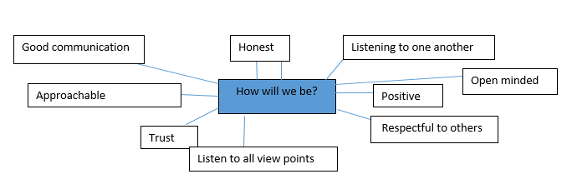
MINUTES
WELCOME
- PT welcomed everyone and thanked all attendees for coming. PT highlighted that the meeting was a valuable opportunity to share important updates and news. The Parent Forum meeting then commenced.
Successes
- PT began by celebrating successes and invited all parents to share any achievements or positive experiences they felt had taken place during the term.
- Parent rep shared that the Young Voices event was amazing and thoroughly enjoyed by the children. They also expressed appreciation for the extensive planning and effort that went into making the event such a success.
- Parent rep noted that the baby chicks and tortoises have brought a great deal of happiness to the children.
- Parent rep shared that the Year 1 multi-skills event was a success, and the children seemed to really enjoy the event.
- Parent rep reported that swimming sessions have run very smoothly, and the children seem to have thoroughly enjoyed them.
- Parent rep noted that information on ClassDojo for 4MV has been easy to find and access.
Feedback on dojo & communication
- PT informed all parent reps that the school is reviewing how effective ClassDojo has been as a communication tool. It was noted that when staff post a story on the main page, they do not always receive notifications of parent comments, as this feature is only available in the paid version of ClassDojo. The school considered turning off the messaging facility but decided against it, as it is valuable for seeing messages. Parents were advised to send a private message directly to the teachers if their comment does not get responded to.
- PT informed parent reps that we will be having a staff meeting with some further training on ClassDojo to ensure consistency in the style of messages across all teachers. While teachers were initially given the opportunity to use their own individual style during the trial, feedback from parents has led the school to want to adopt a more uniform approach to messaging, ensuring clarity and consistency.
- Feedback from parent reps highlighted that more detailed information on events is needed, as it can be difficult for parents to scroll through and find everything. Suggestions included: clearly indicating which parent to contact and ensuring messages are sent to both where appropriate, making PE day schedules more explicit, and providing more detail about coffee mornings and other events.
ACTION:
- Ensuring messages are sent to both parents where appropriate
- Teachers to ensure they are making PE day schedules more explicit
- Inclusion team to provide more detail about coffee mornings and other events.

Engaging all parents
Parent survey
- PT advised that the recent parent survey received very few responses, making it difficult to gather meaningful evidence or feedback. The group discussed ways to engage parents and increase participation.
- Parent reps suggested ideas from other schools, such as hosting informal meetings specifically for fathers to share their views, as these perspectives can be valuable and offer a different viewpoint. They also proposed holding classroom celebrations after school to encourage parent involvement.
- Additionally, a discussion took place regarding whether teachers are aware of who their parent rep is and whether both teachers and parents clearly understand the roles and responsibilities of parent reps.
ACTION:
- Discuss with teachers role of parent reps and then discuss in next Parent Forum
FOBS
- HS informed everyone that the recent FoBilicious event received positive feedback. An Easter egg raffle will take place at the end of the term, with a poster to be released soon. There will also be a rebrand and relaunch, featuring a new logo and a new website. HS mentioned that volunteers are needed to help with the upcoming Summer Fair.
AOB
- Parent reps asked for more information about when the Year 6 hoodies would be distributed.
- They also inquired about the outcome of the school dinners tasting, noting that children are still not enjoying the meals.
ACTION:
- Year 6 teacher to re share info regarding leavers hoodies on dojo
- Re share info regarding food tasting

