

HOME SCHOOL AGREEMENT

Review Date: February 2027
Published: February 2026

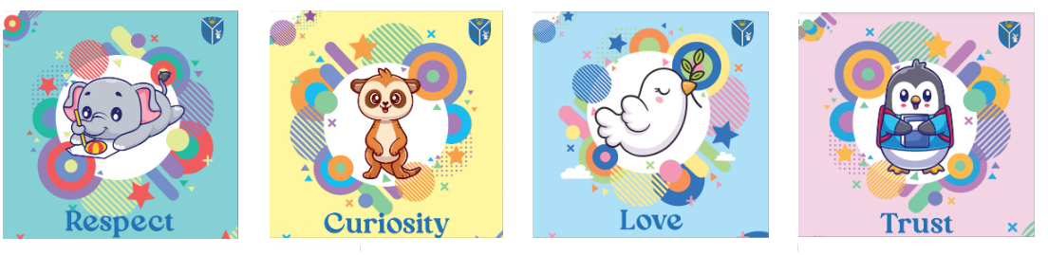



AS A PARENT / CARER I WILL DO MY BEST TO:

- Understand and respect the Parent and Visitor Code of Conduct
- Set-up the right conditions for my child to be a great learner e.g. enough sleep, positive encouragement, a good breakfast, share a love of books.
- Read the letters and emails from school.
- Make sure that my child arrives at school on time, is present for their registration time, in full named uniform.
- Ensure my child has all their correct clothing and footwear for P.E and swimming.
- Make sure that my child attends regularly and notify the school before 9am each day that my child is absent.
- I will promote the school values of Trust, Respect, Curiosity and Love and support The School Charter
- Take opportunities to discuss my child’s progress with their Class Teacher
- Ensure homework is completed on time and encourage my child in their work at school.
- Support the school in fundraising and other activities.
- Be active in life of the school by coming to parent’s evenings, workshops and events.
- Make time to discuss daily school life with my child.
- When I am at school, I will behave in a polite and respectful way to staff, other parents and children.
- Not take holidays during term time, as I understand how much it can setback my child.
- Encourage my child to try their best and celebrate their efforts.
- If I have a problem I will talk in person to the Class Teacher.
- When I park my car, I will not park on double yellow lines, blocking the road, driveways or pedestrian crossing and be respectful of our neighbours.
- I will drive safely in the areas around school and park carefully being mindful of children and neighbours in our community
- I will support the school’s internet and social media agreement.

BY WORKING TOGETHER YOUR CHILD WILL:

- Uphold the school values of Trust, Respect, Curiosity and Love and support The School Charter
- Wear full school uniform, look smart and feel pride in themselves.
- Bring the correct equipment to school for lessons and P.E, swimming and trips.
- Feel calm and safe by attending school every day and on time.
- Work hard and always try to do their best.
- Do their class work and homework on time and best with their best effort.
- Feel safe - tell someone if you are unhappy or worried..
- Be polite to everyone at school and home.
- Let the Class Teacher know if they do not understand their class work and / or their homework.

AS A SCHOOL WE WILL:

- Uphold the school values of Trust, Respect, Curiosity and Love and support The School Charter
- Communicate in a clear, timely way via email, text, letter, website and phone.
- Expect correct school uniform is worn at all times and provide regular times to buy pre-loved uniform.
- Encourage all children to arrive at school on time and to attend school regularly.
- Take your concerns seriously and work with you to find solutions to meet the needs of all children, so they can achieve their full potential.
- Help teach all children to have high self-esteem.
- Discuss with parents / carers the problems of individual children and pride in who they are.
- Give advance notification of important dates.
- We will contact you if your child is absent without prior notification.
- Report regularly on your child’s progress.
- Treat your child as an individual.
- Give information to parents / carers about school activities.
- Develop your child’s learning skills and self-confidence.
- We will celebrate and share with you your child’s efforts.

Pupil name: | ………………………………………………………………………………………………………………………
Pupil date of birth: | ………………………………………………………………………………………………………………………
Parent signature: | ………………………………………………………………………………………………………………………

