

BURSTOW PRIMARY SCHOOL

ANTI-BULLYING POLICY

Review Date: November 2026
Agreed by Governors: November 2025

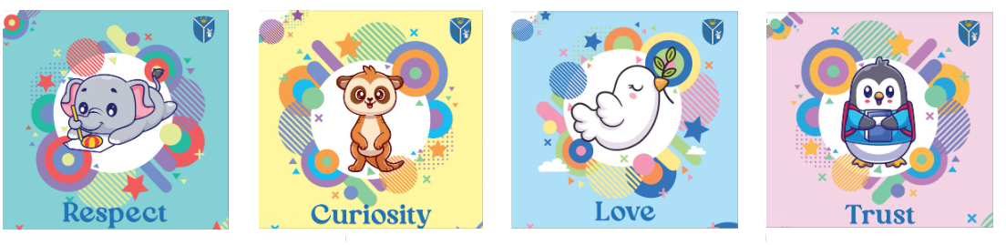

ANTI-BULLYING POLICY

Bullying is unacceptable and will not be tolerated in our school.

What is bullying?

Bullying is the repetitive, intentional hurting of one person or group by another person or group, where the relationship involves an imbalance of power.

We look for four key factors when identifying behaviour as bullying:

- Repetition – the behaviour is not a one-off.
- Intentional – the behaviour was not an accident, or incidental.
- Hurtful – the behaviour is harmful.
- Power – there is a real or perceived imbalance of power.

What does an imbalance of power mean?

An Imbalance of Power: Children who bully use their power – such as physical strength, access to embarrassing information, or popularity – to control or harm others. Power imbalances can change over time and in different situations, even if they involve the same people.



Insult

I
nsult

There is no imbalance of power here. It is a conflict, but not bullying.

Conflict in relationships

Falling out with others is part of growing up (and indeed being an adult). Conflict between friends is something that happens and something that we take seriously as a school. Friendships are incredibly important for all people, but for children, friendships are significantly influential in their lives. Belonging to a particular group sets the tone of a child’s everyday experience and finding a niche is a crucial part of a child’s development.

It is vital not to confuse relational conflict with bullying. Whilst this type of conflict can be very difficult for the children involved (and sometimes families), it is not the same thing as bullying.

HOWEVER – we will take action to address relational conflict, as this conflict affects children’s wellbeing, ability to learn and can escalate into bullying behaviour.

Features of ‘relational conflict’ that are different to bullying:
- Both parties are genuinely upset.
- There is an equal balance of power.
- Effort is made to resolve the problem.
- Both parties have some responsibility for the conflict.
- Neither party are trying to gain something.



Stop it!

Insult

Insult

Insult

There is an imbalance of power here – repetition and threat.



Stop!

I don’t like it!

Rumour spread

Insult

Insult

Bullying Behaviours

Physical behaviours such as: | kicking, punching, hitting, spitting, pushing, taking or breaking someone’s things, making mean or rude gestures, physical intimidation or any unwanted touch.
Verbal behaviours such as: | name calling, threats, taunting, teasing, inappropriate sexual comments, rumour mongering and disrespect.
Social bullying such as: | leaving someone out on purpose, spreading rumours and other types of ‘aggression within relationships’ (see below)
Cyberbullying such as: | texting, trolling (posting insults, provocations or threats on online forums, such as Facebook pages and newspaper comment forums) and sexting (sending inappropriate messages of a sexual nature)
Prejudice behaviours such as: | homophobic, transphobic, racist, targeted at faith, sexist and disablist. (Bullying can be fuelled by prejudice, we will create a culture where prejudice and hatred is not accepted.)
Bystanding behaviours such as: | Not becoming actively involved in a situation where someone else requires help, passively observing, watching something happening, not intervening or getting help even if someone needs it.

Aggression in relationships

This is behaviour that is intended to harm someone by damaging or manipulating their relationships with others. It can be either bullying or within relationships, depending on whether it meets the bullying definitions.

The impact of this kind of behaviour can be extremely damaging and therefore is something we take very seriously at our schools.

What does aggression in relationships look like?
- Alliance-building (you are my friend, but you don’t like …)
- Rejection or exclusion from groups
- Rumour-spreading
- Eye rolling, the ‘evil’ eye or other negative body language
- Ignoring
- Teasing/embarrassing someone in public.
- Taunting
- Manipulative affection (I will be your friend if…)
- Excluding others from games
This type of behaviour is often very hard to prove, but can be the cause of serious tensions in a group and lead to ongoing issues.

The table below may act as a guide when dealing with conflict issues.

 | • | Everyone is having fun
 | • | No one is getting hurt
 | • | Everyone is joining in
 | • | No one is having fun
 | • | There is a possible way to solve the problem
 | • | Someone is being hurt on purpose
 | • | Someone is reacting to a strong feeling
 | • | Does not happen again or only happens once
 | • | Someone is being hurt Several Times On Purpose either with actions or words
 | • | Happens more than once

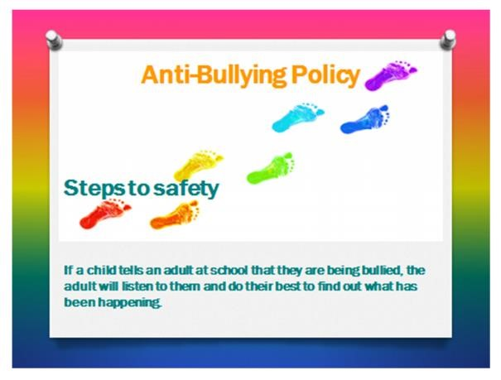
School
Any form of bullying will be treated seriously. Staff will ensure they investigate all incidents, listening to all involved.
The following incremental steps will be taken in response to reported incidents. The incident will be recorded using CPOMS (Child Protection Online Monitoring System) recording software.
A designated member of staff from the leadership team will manage incidents or a parental concern.
Some strategies to support children may include:
- An agreed calm place to take themselves to at break or lunch play if they need somewhere to go.
- Named trusted adult/s
- Zoning of playgrounds
This list is not exhaustive but an example of the ways we might help children who need it.
Whilst we work hard to stop bullying as quickly as possible, interventions and support can take time to have an impact. What we can guarantee, is that repeat incidents will be dealt with robustly.

All behaviours are dealt with according to our Behaviour for Learning Policy. However, in the case of bullying, some additional steps may be taken.

Pre-Stage- A crucial first step

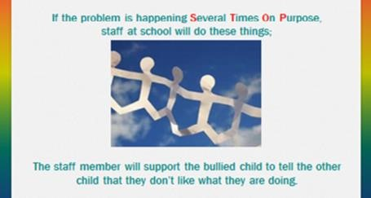

Pre-Stage- Bullied child, with support of adult, will tell the child showing bullying behaviours that they don’t like what they are doing. THIS IS A CRUCIAL FIRST STEP. The incident will be recorded (CPOMS).

This meeting between the children should be conducted by an adult in school and where possible the class teacher should be present. At this stage, both parents/carers should be invited into school separately to discuss incidents and actions and be issued with a copy of the anti-bullying policy. (This will be recorded as an action to the initial incident on CPOMS)

Stage One

Stage 1- If repeat incidents or other bullying behaviour occurs, parents/carers of bully and bullied will be informed of issues. A child showing bullying behaviours will be removed from classroom/playground/lunch hall for fixed period. The incident will be recorded (CPOMS) and parents/carers of both children will be informed of this.
The class teacher will seek advice from SLT. This could be a referral to the Learning Mentor or strategies that could be deployed. Both those being bullied and those showing bullying behaviours need educating and supporting to help the behaviours to stop and both of the learners to feel safe.
After every incident, the bullied child will be supported by an adult to tell the child showing bullying behaviours that they don’t like what he or she is doing.

Stage Two
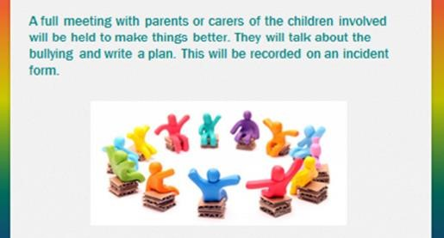

Meetings with parents or carers of the children involved will be held to make things better. They will talk about the bullying and make a plan. This will be recorded on CPOMS. Each parent/carer will be given a copy of their child’s support plan.

Stage 2- A face-to-face meeting with parents/carers of the child showing bullying behaviours.
The learner showing bullying behaviours will be removed from classroom/playground/lunch hall for a further and longer fixed period. Senior Leaders will issue this as an internal exclusion (a child showing bullying behaviours is isolated from the victim and the rest of the class for a period of time). Incident will again be recorded on CPOMS.
Senior Leader to discuss with class teacher and Student the potential need to provide further strategies to address bullying behaviours.
As in Stage 1, the bullied child will be supported by an adult to tell the child showing bullying behaviours that they don’t like what they are doing, after every incident.
This stage may be repeated depending on the nature of the incident and the period of time and circumstances surrounding the last incident.

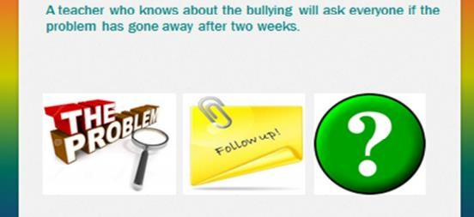

Stage Three

Support from external agencies sought if appropriate.

Stage 3- Headteacher to consider issuing an external suspension. Support from outside agencies sought. A further incident is recorded as repeat bullying- stage 3. Followed up with a letter to parents- see Annex 2.

Equal opportunities, inclusion and access
All pupils will be treated fairly and equally regardless of their race, colour, national or ethnic origin, gender, disability, religion or belief (including non-belief), and sexual orientation. The curriculum is planned to be inclusive and meet the needs and interests of a full range of learners. Activities and resources will be differentiated, and adult support used to ensure that children access the curriculum and make the best possible progress.

The role of the Headteacher
It is the role of each Headteacher to implement the school’s anti-bullying strategy and that staff deal with incidents of bullying. The Headteacher reports to the governing body about the effectiveness of the anti-bullying policy on request.
The Headteacher ensures that all children know that bullying is wrong, and that it is unacceptable behaviour in school. The Headteacher does this at suitable moments, e.g. at the beginning of a term, after an incident, during anti-bullying week or through an assembly, for example.
The Headteacher records any bullying incident in the school on CPOMS software and on safeguarding termly reports. This is to monitor frequency and types of incidents and the pupils involved.
The Headteacher ensures that all staff receive sufficient training so they are equipped to deal with all incidents of bullying.
The Headteacher sets the school climate of mutual respect and praise for success, so children feel important and are part of a friendly, welcoming school and therefore bullying is less likely.

The role of the Governors
The Governing body supports the Heads in all attempts to eliminate bullying from our schools.
The Governing body monitors all incidents of bullying that occur and reviews the effectiveness of the policy each year and/or as situations dictate.
The Governing body will deal with any complaint from a parent/carer in line with the School’s Complaints Policy.

The role of the teachers
We all take bullying very seriously.
If we come across an incident of bullying, we will deal with the situation by taking the incident seriously.
We will follow the school’s Anti-Bullying Policy.
We can talk to a senior member of staff about any concerns that we have.
We all aim to establish a nurturing and caring environment in our classrooms. By praising, rewarding and celebrating the success of all children, we aim to prevent incidents of bullying.
We use class council, circle times, PSHE (Personal, Social Health and Economic Education) and School Parliament to talk about bullying and its impacts.
We will teach the children to recognise bullying and how this is different to rough play/falling out with people.
We will promote assertive behaviour strategies and discuss how to respond to verbal/physical or online attacks.

The role of learning support assistants and other staff who work in school
All staff must be alert at all times both inside and outside the classroom, particularly at playtimes and lunchtimes.
MDMSs (Mid-Day Meals Supervisors) and LSAs (Learning Support Assistants) must inform children’s class teachers of any incidents they have witnessed and tell them what action was taken.
Incidents that occur at playtimes and lunchtimes will be recorded on CPOMS. (Refer to Behaviour for Learning Policy.)

The role of parents and carers
Parents and carers who are concerned that their child might be being bullied, or suspect their child is bullying, should contact their child’s class teacher immediately. It is always best if these situations are dealt with as soon as they occur.

Dealing with incidents of bullying.
Children – if you have been bullied:
- Tell a teacher or another adult in school.
- If you are scared to tell a teacher or adult on your own, ask a friend to go with you.
- Tell your family.
- Communicate through classroom Worry Box and/or Help Cards

Children – if you see others being bullied:
- Tell a teacher or another adult in school.
- Do not be a bystander.
Parents and families
- Be aware of changes in your child’s behaviour that may be symptoms of bullying.
- Contact the class teacher if you are worried. If you have further concerns contact an Assistant Headteacher. (The school office will be able to put you in contact with them.) In the event of continued problems/concerns, additional support can be sought from the leadership team.
- Monitor your child’s use of the internet, especially on social networking sites or chat rooms. Remember most social networking sites (including Facebook) are for age 13+ only.


UK Safer Internet Centre (www.saferinternet.org.uk) offers advice and resources to help tackle cyberbullying. The centre is co-ordinated by a partnership of three leading organisations: Childnet International, the South West Grid for learning and the Internet Watch Foundation.

Incidents outside of school
For bullying outside school and not on school premises, the school may intervene and possibly sanction a pupil (including internal exclusion/fixed term exclusion) if there is a clear link between that bullying behaviour and maintaining good behaviour and discipline among the pupil body as a whole. This will be a matter of judgement for the leadership team.

SUPPORT GUIDE FOR CHILDREN
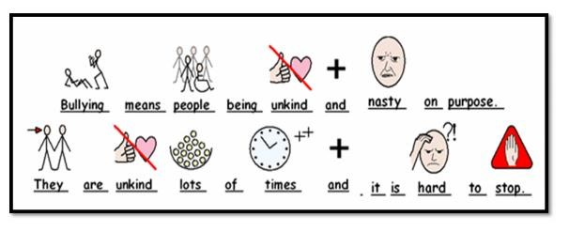



If the problem is happening:

S
everal

T
imes

O
_{n}

P
urpose

A staff member will support
the bullied child to tell the other
child that they do not like what they are doing.

If it happens again it is intentional and will be classed as
bullying behaviours.

Stop!

I don’t like it!

If a child tells an adult at school that they are being bullied, the adult will listen to them and do their best to find out what has been happening.

Bullying can be words or physical actions that are deliberate and repeated over time to make someone else feel uncomfortable about themselves.

If you are being bullied …
- Be firm and clear, strong and reasonable.
- Let someone know.

Afterwards …
- Tell a teacher.
- If you are scared, ask a friend for help

Be clear about …
- What have you done about it already?

How do we stop bullying?
We will not let bullying behaviour carry on.
We will ask the bullied child to join our group.
We will ask the bully to join our game too.

Annex 1: This is a letter to parents that may be used in a case of bullying

Dear……

Thank you for coming in to school to discuss our concerns regarding …(NAME’s) behaviour towards other children. As discussed, this incident has been recorded as the first stage, a ‘one-off’ and is not treated as official “bullying”. However, any further incidents will be classed as bullying behaviours and dealt with in line with our anti-bullying policy (please find attached).

As discussed, the sanction for their behaviour is………………………. As well as this, the support we will put in place for your child following this incident to support them in stopping these behaviours is………
Please discuss our Core Values with ………..and strategies that they can use to make sure they are following them.

If you have any further questions, please do not hesitate to contact a member of senior leadership.

Yours sincerely

Annex 2
SAMPLE LETTER TO PARENTS

Dear …….
I am writing to inform you that (NAME) has been involved in an incident where he/she has shown further bullying behaviours towards another child/other children. As this has happened following initial discussions around what constitutes bullying behaviours and the previous warning, this is now classed as bullying behaviours and will be recorded as stage….. in line with our anti-bullying policy, which was issued during the first meeting we had together.
We do however recognise that very few children who engage in these behaviours are fully aware of the impact of the short-term and long-term scars of children targeted by bullying behaviour. These behaviours cannot and will not be tolerated at Burstow Primary School. We want to ensure that there are no negative consequences suffered by either the victims of bullying behaviours or those who have inflicted distress on their peers.
As a school, we understand the importance of our partnership with you and, therefore, ask if you can take some time to speak about this very important issue with ……… so they can be clear that bullying behaviours towards others is not at all innocent behaviour and that it can have devastating consequences to both its perpetrators and victims. For support with your conversations, the Anti-bullying Alliance website has tips for parents regarding this, these can be found via this link: My child has been accused of bullying others | Anti-Bullying Alliance . ( Delete if not appropriate…Please discuss what it means to be a bystander, and empower them to take a stand when witnessing unkind behaviours.)

As a sanction for their behaviour they have/will………………………. As well as this, the support we will put in place for your child following this incident to support them in stopping these behaviours is……… If you have any further questions, please do not hesitate to contact the Headteacher.

Yours sincerely

