

LOCKDOWN PROCEDURE

Review Date: November 2026
Published: November 2025



Introduction

‘Lockdown’ procedures should be seen as a sensible and proportionate response to any external or internal incident which has the potential to pose a threat to the safety of staff and pupils in the school. Procedures should aim to minimise disruption to the learning environment whilst ensuring the safety of all pupils, staff and visitors.

‘Lockdown’ procedures may be activated in response to any number of situations, which may include:

- A reported incident/civil disturbance in the local community (with the potential to pose a risk to staff and pupils in the school);
- An intruder on the school site (with the potential to pose a risk to staff and pupils);
- A warning being received regarding a risk locally, of air pollution (smoke plume, gas cloud etc.) or chemical, biological or radiological contaminants;
- A major fire in the vicinity of the school;
- The close proximity of a dangerous dog/animal roaming loose.
- An internal incident (with the potential to pose risk to staff and pupils);

‘Lockdown’ Alert

The nominated Lockdown Manager at the school is the Headteacher or a designated member of the senior leadership team; they will initiate, manage and conclude the ‘lockdown’. They will also communicate with the emergency services. The role and responsibilities of the Lockdown Manager are recorded in Appendix 1.

If there is obvious and imminent danger, that a ‘Lockdown’ can be initiated by the staff member who has witnessed the threat.

The fire alarm will not be used to alert staff of the need to ‘lockdown’ to avoid potential confusion. If the fire alarm sounds during a ‘lockdown’ it is to be ignored unless smoke or flames are directly visible and pose an immediate threat to your location.

Lockdown Arrangements

Partial Lockdown

Staff and children will be alerted by 3 short blasts using the Lockdown Alarm
The end of the lockdown will be signalled by the Lockdown Manager saying “Lockdown Clear” as they walk around the building and through the radio (walkie talkie). This will also be sent on wattsapp and email.

In a partial ‘lockdown’ staff and pupils must remain in the school building and all doors and windows leading outside must be locked. No one can be allowed to enter or leave the building; however teaching and work should continue as usual if practicable to do so. This may be as a result of a reported incident/civil disturbance in the local community with the potential to pose a risk to staff and pupils in the school, but whereby that risk is not immediate. It may also be as a result of a warning being received regarding the risk of air pollution, etc. especially any warning from the emergency services.

Immediate action
- All outside activity to cease, pupils and staff return to the building. All staff must have access to a walkie/talkie if working outside (with or without children).
- All staff and pupils remain in the building and all external doors and windows to be locked shut, other than those as designated emergency exits.
- Free movement may be permitted within the building dependent upon circumstances.
- In the event of air pollution, chemical, biological or radiological contaminants issue, air vents, fans, heating and air conditioning systems must be closed or turned off.
- Use anything to hand to seal up all the cracks around doors and any vents into the room – your aim is to minimise possible ingress of pollutants.
- Staff should await further instructions.

All situations are different. Once all staff and pupils are safely inside, senior staff will conduct an ongoing and dynamic risk assessment based on any advice received from the Emergency Services.

Communication during a ‘partial lockdown’ will be via the school’s radio (walkie talkie) system, email system, internal phone system or direct communication from the Lockdown Manager.

A ‘partial lockdown’ may also be used as a precautionary measure; putting the school into a state of readiness (whilst retaining a degree of normality) should the situation escalate.

Emergency Services will advise as to the best course of action in respect of the prevailing threat.

Staff and pupils remain in ‘lockdown’ until it has been lifted by the Lockdown Manager or senior member of the emergency services.

Full ‘Lockdown’

Staff and children will be alerted by the Lockdown Alarm
The end of the lockdown will be signalled by the Lockdown Manager saying “Lockdown Clear” as they walk around the building and through the radio (walkie talkie). This will also be sent on wattsapp and email.

This signifies an immediate threat to the school and may be an escalation of a partial ‘lockdown’. The aim of a full ‘lockdown’ is for the school and its rooms to appear empty.

Immediate action
- All pupils/staff to stay in their classroom or move to the nearest classroom;
- Office staff should remain in their office;
- All outside activity to cease, pupils and staff return to the building or exit the site and proceed to an agreed safe location outside the school gates. Staff to dynamically risk access dependant on time of day and phone emergency services immediately. (Use walkie talkies to communicate the alert to staff at break/lunch/outdoor learning/PE times).
- All communications will be sent via Watts App to the Burstow Emergency Group
- External doors locked. Classroom doors locked (where a member of staff with a key is present) or barricaded;
- Windows locked, blinds drawn, internal door windows covered (so an intruder cannot see in);
- Pupils and staff to sit quietly out of sight and where possible in a location that would protect them from gunfire, bullets can go through glass, brick, wood and metal. Consider locations behind substantial brickwork or heavy reinforced walls;
- Lights, smartboards and computer monitors turned off;
- Pupil’s mobile phones to be turned off, staff mobiles to be set to silent with no vibrate;
- A register (paper copies kept in class rooms and to hand during outside activities) to be taken of all pupils and staff in each classroom/office;
- Communicate register of staff and pupils to the Lockdown Manager;
- Staff should await further instructions.

During the ‘lockdown’, staff will keep agreed lines of communication open but not make unnecessary calls as this could delay more important communication.

Staff and pupils remain in ‘lockdown’ until it has been lifted by the Lockdown Manager or senior member of the emergency services.

Communication with Parents and Carers

The ‘lockdown’ manager, via the office will inform parents and carers that the school is in lockdown via the school’s messaging service, the below template will be used:

‘The school is in a lockdown situation. During this period phones will not be answered, all doors are locked and nobody can enter or leave the site. We are working to ensure the safety of all our children. DO NOT come to the school until the incident has been resolved. We will keep you informed as best we can.’

During a ‘lockdown’ no members of the public will be allowed into the school and parents/carers will be told not to travel to the school.

All staff, pupils and visitors to the school will not be allowed to leave the school until the lockdown has been declared over.

Parents and carers must not try to contact the school during the ‘lockdown’.

Pupils will not be dismissed to parents or carers until the incident has been declared over by the Lockdown Manager or senior member of the emergency services.

Appendix 1 –Roles and Responsibilities

Lockdown Manager

This is the Headteacher. The Deputy Headteacher is the deputy Lockdown Manager in case the Lockdown Manager is not on the school site at the time a lockdown is declared.

- Alert all staff and pupils of the need to ‘lockdown’ the school.
For partial ‘lockdowns’ this will be achieved via three short whistles on the walkie-talkies and for full ‘lockdowns’ this will be via continuous intermittent sounder created from the school’s fire alarm system – activated by key switch in the front office.
- Inform emergency services immediately.
- Inform parents/carers via the school’s message system.
- Ensure communication networks with all key staff are established.

Classroom Based Staff

- Lock all external doors and windows.
- If full lockdown, secure all internal doors – lock or barricade.
- Close and secure all windows.
- Close all curtains or blinds.
- Ensure pupils are in a safe place in the classroom i.e. sheltered by a substantial wall away from doors and windows.
- Ensure you have a means to communicate with the lockdown manager.
- Turn off all IT equipment.

Office Based and Site Staff

- Ensure all entrances are locked and secured.
- Close and secure all windows.
- Turn off all IT equipment.

Appendix 2 – Communication Flow Chart

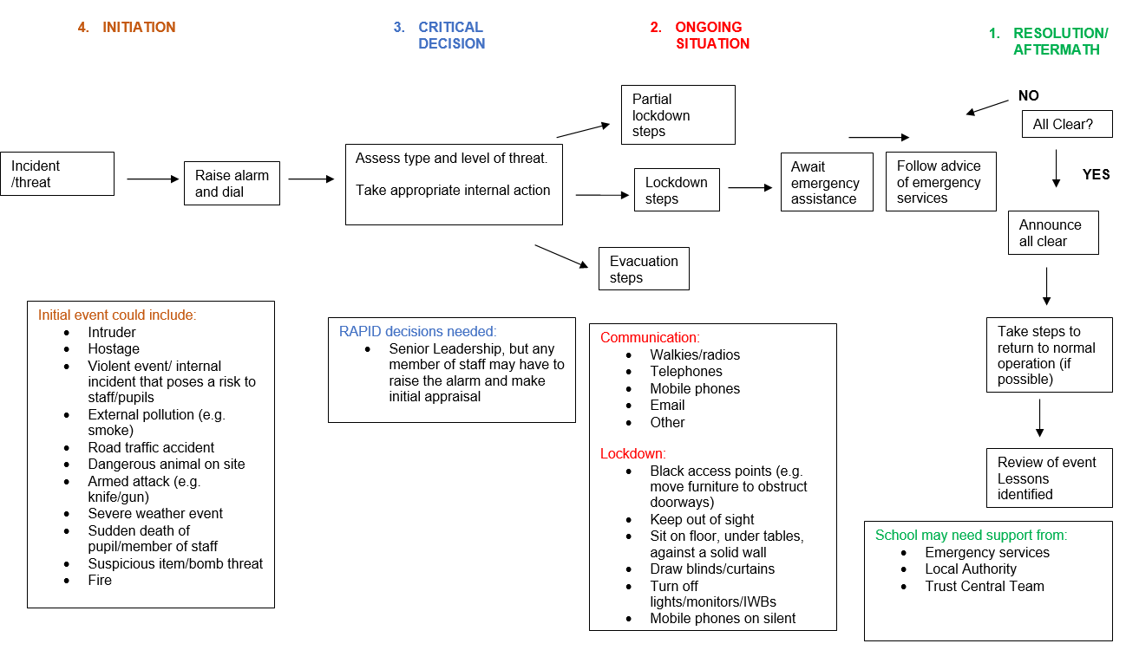

Appendix 3 – Sample letter to parents/carers

Dear Parents and Carers,

Re: Emergency Lockdown Procedure

Our primary aim as a school is the safety and wellbeing of our pupils, to support us in achieving this we have many policies in place, including how we would respond to a potential incident either in the community or directly affecting the school.

One of these policies is our ‘Lockdown’ procedure, the aim of this policy is to support our staff in safeguarding our pupils from a variety of potential hazards that many arise, these include:

1. A reported incident, disturbance in the local community;
2. An intruder on the site;
3. A warning being received regarding a local risk of air pollution (smoke plume, gas cloud etc.);
4. A major fire in the vicinity of the school;
5. The close proximity of a dangerous dog.

Our procedure aims to minimise disruption to the learning environment whilst ensuring the safety of all pupils and staff.

In the event of an emergency that requires the school to be locked down the following actions may be taken, please note this is not an exhaustive list and is being provided as a summary only, exact actions will be dependent on the incident:

- Staff will ensure all pupils are inside the school buildings and lock any outside doors and close any windows that may be open;
- If pupils are outside, staff will bring them back into their classrooms;
- A register will be taken and any pupil not present will be notified to senior staff who will arrange a search for the missing pupil;
- Site and office staff will ensure all external doors are secured and closed;
- Emergency services will be notified;
- A message will be sent to parents and carers via our normal systems to advise of the emergency;
- Pupils will not be released from the school until the all clear is given;
- Parents/Carers MUST NOT try to contact the school or come to the school until the all clear has been given. This can both block essential routes of communications and hamper the emergency services.

We will shortly be carrying out an emergency drill with the staff and pupils to ensure that everyone is clear on what they have to do.

In the unlikely event that we have to put this process into action we need to ensure that parents are aware of the arrangements, as outlined above.

Appendix 4 – Social story similar to this shared with children and families

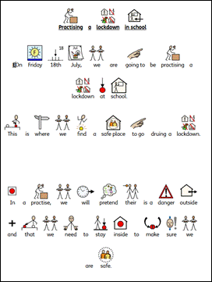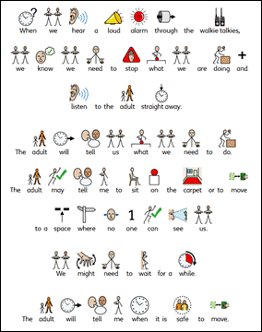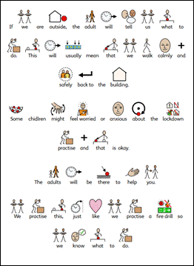

Appendix 5 – Lockdown Practice Assembly shared with children

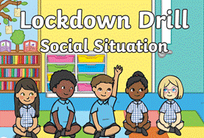 | 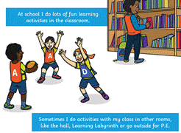 | 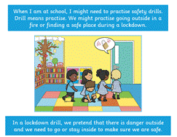
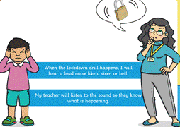 | 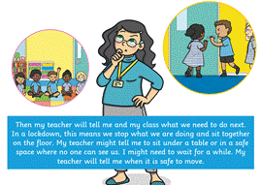 | 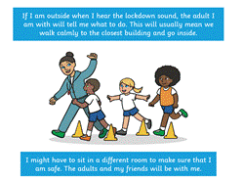
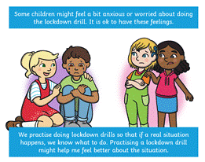 | 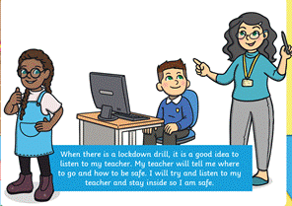

Appendix 6 - Lockdown scenarios used as part of Staff training.

Lockdown scenario 1
At approximately 11.30am, an adult buzzes at the gate and says they have come to collect their child for a dental appointment. The office ask the name of the parent and which child they are collecting for clarification. As this is asked, a car drives out and the adult walks through the car gate.
As they walk down the drive, they do not walk to the office but instead, walk across the Key Stage 2 playground. The office can no longer see the person on the CCTV. They enter the building via Key Stage 2. A member of staff speaks to them and asks who they are here to see and have they signed in? They say they have not signed in and the member of staff sends them off up the corridor, unaccompanied. They do not arrive at the office. The member of staff calls the office to inform a parent has entered via key stage 2 and is heading to them. The office advise they have not arrived.
It is not evident where the adult is on site.

Lockdown scenario 2
An adult enters the school site through the main gate and walks down the school drive. When they arrive at reception, they are buzzed in. They begin shouting at office staff that they want their child immediately. The staff explain the child is not in school today. When they are asked to calm down, they pull out a knife and begin to wave this toward staff.

Lockdown scenario 3
An anonymous call is made to school to advise that there is a dangerous adult in the area that has been seen close to the school site. They are armed with a knife and have been exhibiting dangerous behaviour towards members of the public. The police and have been informed. They anonymous caller wanted us to be aware as they had been seen near school. On the CCTV, the office team see someone hanging around at the gate and the person enters the site by climbing over the main gate. It appears that they are carrying something. There are a class of children on the field doing PE and a year group in the outdoor learning area.

