No Outsiders whole school overview

 |  | Autumn 1 | Autumn 2 | Spring 1 | Spring 2 | Summer 1 | Summer 2
EYFS | Book | 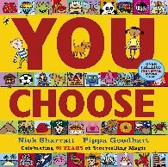 | 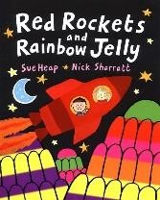 | 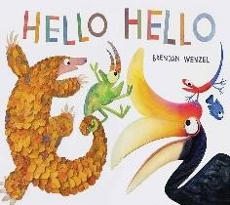 | 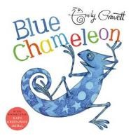 | 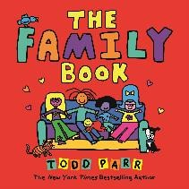 | 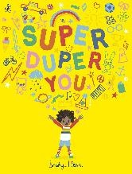
EYFS | Book | ‘You Choose’ by Nick Sharratt and Pippa Goodheart | ‘Red Rockets and Rainbow  Jelly’ by Sue Heap and Nick  Sharratt | ‘Hello, Hello’ by Brendan  Wenzel | ‘Blue Chameleon’ by Emily  Gravett | ‘The Family Book’ by Todd Parr | ‘Super Duper You’ by Sophy  Henn
EYFS | Theme | Making choices. | Friendship  Being different. | Friendship.  Being different. | Friendship.  Being different. | Different families. | What makes us different.
EYFS | Key Elements | I can choose.  What do I choose?  Do we have to like the same thing?  Is it ok to like different things?  I can make my own decisions; I can tell you things I like and don’t like;  I can ask others what they think. | It’s ok to like different things.  What does my friend like? I know my friends like different things to me and I know we can still be friends.  Imagine if we all liked the same things - how would our class work? | We are all different.  What can I say when I meet someone new?  I know that in my class, we are not all the same.  I know we are all different. I know I can make friends with different people. | Everyone is different.  I know everyone is different in my class.  I can make friends with anyone.  You don’t have to change to be like everyone else. Do you have to look like someone to be their friend? Do we have friends in our class who look different? | I know what a family is.  I know what families can look like.  I know all families are different.  Do all families look the same? Who do you love in your family? | I know my feelings can change. I know I am growing up and I can change.  What can we be proud of in our class?
EYFS | RSE objective | Respectful Relationships The importance of respecting others, even when we are different from them or make different choices or have different preferences or beliefs. | Respectful Relationships The importance of respecting others, even when we are different from them, or make different choices or have different preferences or beliefs. | Caring Friendships How important friendships are in making us feel happy and secure and how people choose and make friends. | Caring Friendships How important friendships are in making us feel happy and secure and how people choose and make friends. | Families and People who Care for Me  That other families, either in school or in the wider world, sometimes look different from their family, but that they should respect those differences and know that other children’s families are also characterised by love and care. | Respectful Relationships The importance of self-respect and how this links to their own happiness.

Y1 |  | Autumn 1 | Autumn 2 | Spring 1 | Spring 2 | Summer 1 | Summer 2
Y1 | Book | 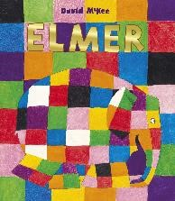 | 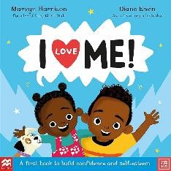 | 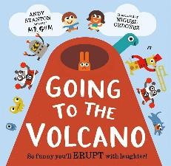 | 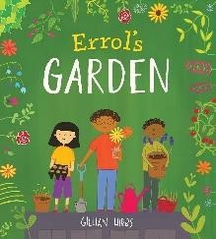 | 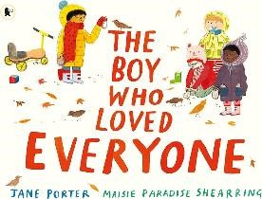 | 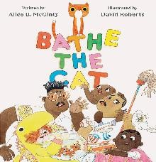
Y1 | Book | ‘Elmer’ by David Mckee | ‘I Love Me’ by Marvyn Harrison | ‘Going to the Volcano’ by Andy  Stanton | ‘Errol’s Garden’ by Gillian Hibbs. | ‘The Boy who Loved Everyone’ by Jane Porter | ‘Bathe the Cat’ Alice B McGinty and David Roberts
Y1 | Themes | Self-respect.  Celebrating who I am. | Self-respect and differences. | Joining in. | Helping people and asking for help. | Feeling welcome.  Family relationships and love. | Working together.  Different families.  LGBT+ families.
Y1 | Key Elements | I like the way I am.  Do I have to change?  Does someone have to change to be like others?  What do we say about being different in our school? I know ways to welcome people.  I know the ways we are different.  Why is this story about No Outsiders? | What’s great about me? If you feel confident, what does that mean?  I know I am different.  I can tell you how I’m different. I can tell you what is great about me.  Why is this story about No Outsiders? | What does it feel like to join in?  I know how it feels to be left out.  Why is this story about No Outsiders? | How do I ask for help?  How can neighbours help each other?  Why is this story about No Outsiders?  I know I can ask for help if I need it.  I know how to ask for help. I know how to respond if someone asks for help. | How do I make you feel welcome?  I know we all have feelings. I can choose when and how to share my feelings.  Do we love everybody?  Who in our lives do we love? What is it about your special person that makes you love them?  How is saying you love someone different to them being your friend?  How does it feel when your special person says they love you?  Why is this story about No Outsiders? | How do we solve a problem? I can work as a team to solve a problem.  I know that families can look different.  The family in the book all love each other - how do we know?
Y1 | RSE objective | Respectful Relationships The importance of self-respect and how this links to their own happiness. | Respectful Relationships The importance of self-respect and how this links to their own happiness. | Caring Friendships  How important friendships are in making us feel happy and secure and how people choose and make friends. | Respectful Relationships The importance of permissionseeking and giving in relationships with friends, peers and adults. | Respectful Relationships Practical steps they can take in a range of contexts to improve or support respectful relationships. | Families and People who Care for Me  That other families, either in school or in the wider world, sometimes look different from their family, but that they should respect those differences and know that other children’s families are also characterised by love and care.

Y2 |  | Autumn 1 | Autumn 2 | Spring 1 | Spring 2 | Summer 1 | Summer 2
Y2 | Book | 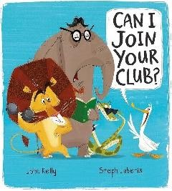 | 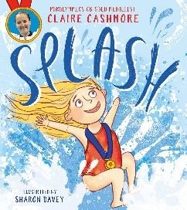 | 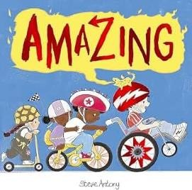 | 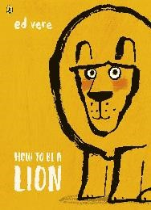 | 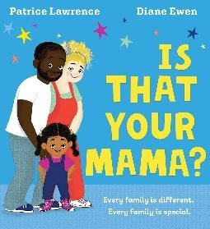 | 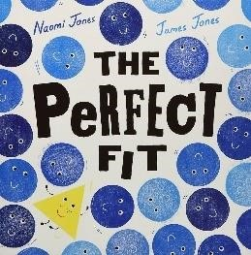
Y2 | Book | ‘Can I join your club?’ by John  Kelly and Steph Laberis | Splash’ by Claire Cashmore | ‘Amazing’ by Steve Antony | ‘How to be a Lion’ by Ed Vere | ‘Is that your mama?’ by Patrice  Lawrence and Diane Ewen | ‘The Perfect Fit’ by Naomi and  James Jones
Y2 | Themes | Inclusion and welcoming everyone. | Dreams and achievements.  Inclusion.  Protected characteristic: disability. | Friendship.  Inclusion.  Protected characteristic: disability. | Self-confidence. Being different. | Different families.  All families are special.  Protected characteristic: race. | Inclusion – fitting in.
Y2 | Key Elements | To welcome different people. I have friends who are different to me.  I don’t leave people out. Why is this about No Outsiders? | To know I can be what I want to be.  How do I achieve my dreams?  I know we all have dreams. I know that sometimes dreams can seem impossible to achieve.  I know why it’s important not to give up.  Why is this about No Outsiders? | What makes a good friend? I know what a friend is. I know how to be a good friend.  What does No Outsiders mean?  Why is this story about No Outsiders? | Should I change?  I know we are all different.  I know sometimes people want you to change.  I know what confidence is. I know how to help someone feel more confident. Why is this about No Outsiders? | I know what a family is. I know that families look different.  I can tell you about different types of families.  What do all families have in common?  Are all families the same?  Do all families look the same? Do all people in families look the same?  Why is this story about No Outsiders? | I know how it feels to join in or be left out of a game. I can think of ways to make sure everyone is included. Why is this story about No Outsiders?  How might our class be like the triangle and the shapes?
Y2 | RSE objective | Caring Friendships  That healthy friendships are positive and welcoming to others and do not make others feel lonely or excluded. | Respectful Relationships The importance of self-respect and how this links to their own happiness. | Caring friendships The characteristics of friendships, including mutual respect, truthfulness, trustworthiness, loyalty, kindness, generosity, trust, sharing interests and experiences and support with interests and experiences and support with problems and difficulties. | Caring Friendships  How to recognise who to trust and who not to trust, how to judge when a friendship is making them unhappy or uncomfortable, how to manage conflict, how to manage these situations and how to seek help or advice from others if needed. | Families and People Who Care for Me  That families are important for children growing up because they can give love, security and stability.  That others’ families, either in school or in the wider world, sometimes look different from their family, but that they should respect those differences and know that other children’s families are also characterised by love and care. | Caring Friendships How important friendships are in making us feel happy and secure and how people choose and make friends.

Y3 |  | Autumn 1 | Autumn 2 | Spring 1 | Spring 2 | Summer 1 | Summer 2
Y3 | Book | 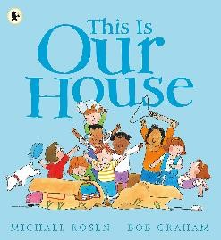 | 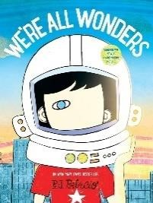 | 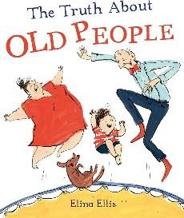 | 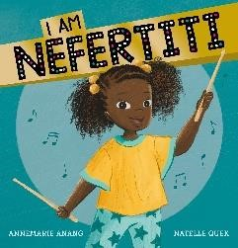 | 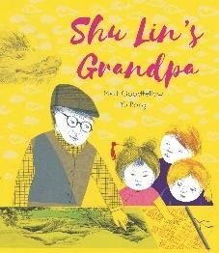 | 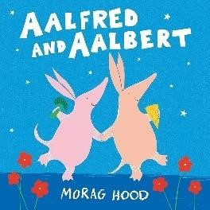
Y3 | Book | ‘This is our House’ by Michael  Rosen and Bob Graham | ‘We’re all Wonders’ by RJ  Palacio | ‘The Truth about old people’ by  Elina Ellis | ‘I am Nefertiti’ by Annemarie  Anang and Natelle Quek | ‘Shu Lin’s Grandpa’ by Matt  Goodfellow and Yu Rong | ‘Aalfred and Aalbert’ by Morag  Hood
Y3 | Themes | Understanding discrimination. Making people feel included. | Being proud.  We are all different.  Protected characteristic: Disability | Recognising and challenging stereotypes.  Protected characteristic: Age | Showing respect.  Protected characteristic: race. | Showing empathy.  Protected characteristic: race. | Having things in common. Community cohesion.
Y3 | Key Elements | What is discrimination? I know what discrimination means.  I can recognise discrimination. I know how to make sure discrimination doesn’t happen in our class.  What do we say in our school about differences and discrimination?  Why is this book about No Outsiders? | I know we are all different. I know sometimes people try to fit in and I know why.  I can recognise my differences.  I am proud of my differences. We’re all wonders – what makes us unique?  We are all different and we all belong in our class. Why is this about No Outsiders? | What is a stereotype? I know what a stereotype is and can recognise stereotypes. I can challenge stereotypes. Where do stereotypes come from?  If we don’t challenge stereotypes, what can happen? Do they become more widely believed?  How is this lesson about No Outsiders? | Are names important? I know people’s names are important.  It’s important to get someone’s name right.  If we are unsure how to pronounce a name, what could we do?  How is this lesson about No Outsiders? | What does it feel like to be new in class?  How might if feel if you don’t know anyone?  How might if feel if someone has a different language to everyone else?  What does empathy mean and how can we show it? Why is the story about No Outsiders? | How do we find common ground?  I know that there are more things we have in common than divide us.  What things do we have in common in class? What does community cohesion mean?  In what ways are we different where we live and how do we work together. Why is this about No Outsiders?
Y3 | RSE objective | Caring Friendships  That healthy friendships are positive and welcoming to others and do not make others feel lonely or excluded. | Respectful  Relationships  The importance of respecting others, even if they are very different from us (for example, physically, in character, personality or background), or make different choices or have different preferences or beliefs. | Respectful Relationships What a stereotype is, and how stereotypes can be unfair, negative and destructive. | Respectful  Relationships  The importance of respecting others, even if they are very different from us (ie physically, in character, personality or background), or make different choices or have different preferences or beliefs.  Practical steps they can take in a range of contexts to improve or support respectful relationships.  The conventions of courtesy and manners.  The importance of self-respect and how this links to their own happiness.  That in school and wider society they can expect to be treated with respect others, and that, in turn, they should show due respect to others, including those in positions of authority. | Caring Friendships  That healthy friendships are positive and welcoming to others and do not make others feel lonely or excluded. | Respectful  Relationships  Practical steps they can take in a range of contexts to improve or support respectful relationships.

Y4 |  | Autumn 1 | Autumn 2 | Spring 1 | Spring 2 | Summer 1 | Summer 2
Y4 | Book | 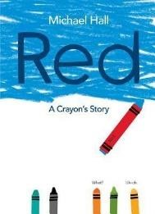 | 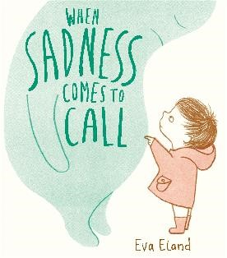 | 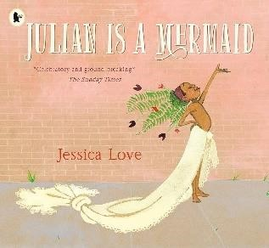 | 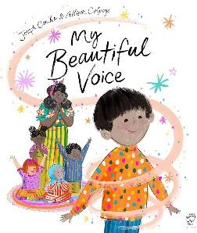 | 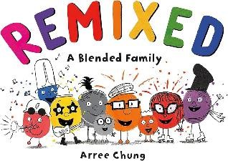 | 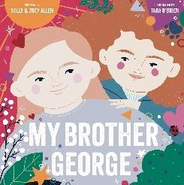
Y4 | Book | ‘Red: A Crayon’s Story’ by  Michael Hall | ‘When Sadness Comes to Call’ by Eva Eland | ‘Julian is a mermaid’ by Jessica  Love | ‘My Beautiful Voice’ by Joseph  Coelho and Alison Colpoys | ‘Remixed’ by Arree Chung | ‘My brother George’ by Kelly and Zoey Allen
Y4 | Themes | Identity and being who you are. | Understanding and managing mental health and wellbeing. | Accepting and understanding differences.  Being non-judgemental. | Finding our voices to speak up. | Families are all different.  Changing families. | How language chosen affects others;  Being non-judgemental.  Protected characteristics: Sex/ gender
Y4 | Key Elements | I know some people change.  I know what judgement is. I know how to be nonjudgemental.  Is it my job to tell someone who they are?  What is the story about?  What is the story’s message?  Why is it about No Outsiders? | What is good mental health? I can recognise when I am feeling sad or unhappy. I have strategies to make myself feel better.  How can we help someone who is dealing with sadness? Why might someone pretend to be happy when they are sad?  Why is good mental health important?  How can feelings of sadness make you feel like an outsider? How can we make sure that nobody in our class feels like an outsider? | How do I show acceptance? I know people can choose what to wear.  I know that people in my community wear different things.  I can be accepting of differences.  What can we do in our school to make sure that everyone feels accepted for the person they are?  Why is this about No Outsiders? | How do I find my pupil voice to speak up?  I know that I have a voice. I can choose to use my voice to add my ideas.  I know that sometimes it feels hard to speak out.  I can find ways to speak up when I am nervous.  How can we make sure that nobody in our class feels like an outsider? | I know how families can change and this can be hard to manage. How can families change?  I understand that family changes are out of my control. What do families look like and how are they different? Some families are extended – what does this mean? What happens when families split up or divorce?  If parents find new partners, what can happen then?  Families are vey different and there isn’t a best model of this. What do you think is the most important thing a family has? | How does the language that I use affect others?  I know that we are all different. I know what judgement is. I understand what it is to be non-judgemental.  I know I can choose to respond in a situation.  When might a person feel like they were being judged? Is gender always obvious? What can we learn from the character in the story? Why is this about No Outsiders?
Y4 | RSE objective | Caring Friendships The characteristics of friendships, including mutual respect, truthfulness, trustworthiness, loyalty, kindness, generosity, trust, sharing interests and experiences and support with interests and experiences and support with problems and difficulties.  How to recognise who to trust and who not to trust, how to judge when a friendship is making them unhappy or uncomfortable, how to manage conflict, how to manage these situations and how to seek help or advice from others if needed. | Caring Friendships The characteristics of friendships, including mutual respect, truthfulness, trustworthiness, loyalty, kindness, generosity, trust, sharing interests and experiences and support with interests and experiences and support with problems and difficulties. | Respectful  Relationships  The importance of respecting others, even if they are very different from us (for example, physically, in character, personality or background), or make different choices or have different preferences or beliefs. | Respectful Relationships The importance of self-respect and how this links to their own happiness. | Families and People Who Care for Me  The characteristics of healthy family life, commitment to each other including times of difficulty, protection and care for children and other family members, the importance of spending time together and sharing each other’s lives. | Caring Friendships  That healthy friendships are positive and welcoming to others and do not make others feel lonely or excluded.  Respectful  Relationships  The importance of respecting others, even if they are very different from us (i.e. physically, in character, personality or background), or make different choices or preferences or beliefs.  The importance of self-respect and how this links to their own happiness.  What a stereotype is, and how stereotypes can be unfair, negative and destructive.

Y5 |  | Autumn 1 | Autumn 2 | Spring 1 | Spring 2 | Summer 1 | Summer 2
Y5 | Book | 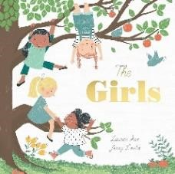 | 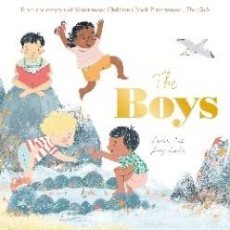 | 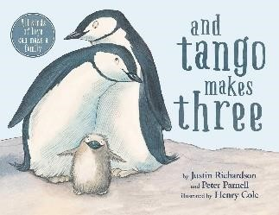 | 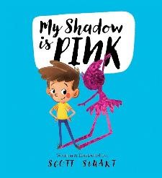 | 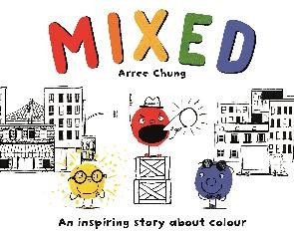 | 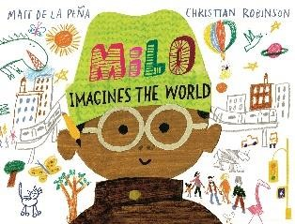
Y5 | Book | ‘The Girls’ by Lauren Ace and  Jenny Lovlie | ‘The Boys’ by Lauren Ace and  Jenny Lovlie | ‘And Tango Makes Three’ by  Justin Richardson and Peter Parnell | ‘My Shadow is Pink’ by Scott  Stuart | ‘Mixed’ by Arree Chung | ‘Milo Imagines the World’ by  Matt de la Pena and Christian Robinson
Y5 | Themes | Exploring friendships.  Exploring gender: girls. | Exploring friendships.  Checking in on people.  Exploring gender: boys. | Different relationships and families.  Expressing opinions. LGBT+ equality, protected characteristics & Equality Act. Protected characteristic: sexual orientation. | Finding self-acceptance and  ‘fitting in’.  Challenging stereotypes. Accepting and understanding differences.  Being non-judgemental. | Recognising racism. Considering responses to racism.  Protected characteristic: race | Issues with judging by appearance.  Being non-judgemental.  Challenging stereotypes.
Y5 | Key Elements | What is a good friend?  I know what a good friend is. I know how important friendship is.  I know sometimes that friendship can go wrong. I value the people around me. How do you become friends with someone?  How does friendship change over time?  Why does celebrating someone’s success make you a good friend?  Why is this book about No Outsiders? | To check in with people.  I know how to work as a team. I know how mental health can be affected by friendship.  I know how to make someone feel valued.  How would you define friendship?  Is friendship always easy? Are friendships different for girls and boys?  Compare the book to ‘The Girls’. Why did the authors separate them into gender? | I know there are different opinions about equality around the world.  I can listen, respond and show respect if I disagree.  I know it’s ok to disagree.  Why might a book be banned? Is it ok for a book to be banned?  Why do you think that this book was banned in some countries?  What do we say at our school about being LGBT+ and protected characteristics? How is this lesson about No Outsiders? | I know we are all different.  I know some people hide who they really are.  I know what self-acceptance is. I know how to help someone be proud of who they are. What do we mean by ‘fitting in’? Why do people feel like they have to ‘fit in’? How might you feel if you thought you didn’t ‘fit in’?  How do I fit in?  How is this lesson about No Outsiders? | I can recognise racism when I see it.  I know how to challenge racist ideas.  What is racism?  How do I challenge racist behaviour or ideas?  Can people with racist ideas change?  Why is this about No Outsiders? | I know appearances can deceive.  I know that it’s hard not to judge someone on their appearance.  I know what non-judgemental means and how I can try to remain non-judgemental. How are people judged by their appearance?  Does this matter? Why does it happen?  What is a stereotype? How can stereotypes be harmful?  Why is this story about No Outsiders?
Y5 | RSE objective | Caring Friendships  That most friendships have ups and downs, and these can often be worked through so that the friendship is repaired or strengthened, and that resorting to violence is never right. | Caring Friendships  That most friendships have ups and downs, and these can often be worked through so that the friendship is repaired or strengthened, and that resorting to violence is never right. | Respectful  Relationships  The importance of respecting others, even if they are very different from us (for example, physically, in character, personality or background), or make different choices or have different preferences or beliefs. | Respectful  Relationships  The importance of respecting others, even if they are very different from us (for example, physically, in character, personality or background), or make different choices or have different preferences or beliefs.  The importance of self-respect and how this links to their own happiness. | Families and People Who Care for Me  That others’ families, in school or the wider world, sometimes look different from their family, but that they should respect those differences and know that other children’s families are also characterised by love and care.  Respectful Relationships The importance of respecting others, even if they are very different from them (for example, physically, in character, personality or background), or make different choices or have different preferences or beliefs. | Respectful Relationships What a stereotype is, and how stereotypes can be unfair, negative and destructive.

Y6 |  | Autumn 1 | Autumn 2 | Spring 1 | Spring 2 | Summer 1 | Summer 2
Y6 | Book | 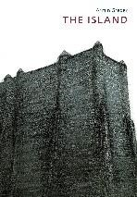 | 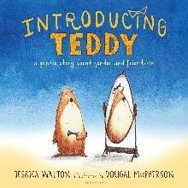 | 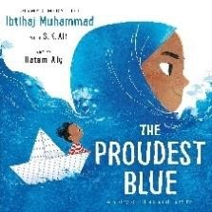 | 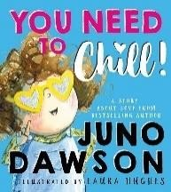 | 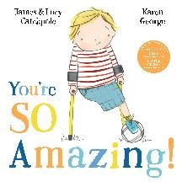 | 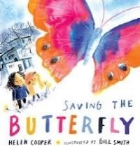
Y6 | Book | ‘The Island’ by Armin Greder | ‘Introducing Teddy’ by Jessica  Walton and Dougal MacPherson | ‘The Proudest Blue’ by Ibtihaj  Mujammad and SK Ali | ‘You Need to Chill’ by Juno Dawson and Laura Hughes | ‘You’re So Amazing’ by James and Lucy Catchpole | ‘Saving the Butterfly’ by Helen  Cooper and Gill Smith
Y6 | Themes | Causes of racism and prejudice.  Protected characteristic: race. | Acceptance and nonjudgement.  Challenging stereotypes.  Protected characteristic: transgender. | New experiences and transitioning.  Respecting differences.  Culture and diversity.  Protected characteristic: race and religion. | Responding to change.  Inclusion.  Learning to be nonjudgemental.  Protected characteristic: transgender. | Attitudes towards disability.  Protected characteristic: disability.  Inclusion and accessibility. | Experiences that shape us.  Refugees.  Protected characteristic: race.
Y6 | Key Elements | I know what prejudice is.  I can recognise prejudice. I know what can happen if prejudice is not challenged. I know ways I can challenge prejudice.  Where do racist ideas come from?  Are children born with racist ideas?  What causes the development of racist ideas?  What can we learn from this book?  What do we say about children who join our school? Why is this about No Outsiders? | How does my language affect a person?  I know that we all change as we grow older.  I know that sometimes, people can hide the person that they really are.  I know how to ensure that my friends trust me.  What is a stereotype and how do stereotypes affect use?  Can stereotypes be harmful?  What is a gender stereotype? Can gender stereotypes be harmful?  Why might a person worry about gender stereotypes? What does the term ‘transgender’ mean? Why is this story about No Outsiders? | To consider how new experiences affect us.  How can transitioning be hard to do?  I know how people in my community are different. I can show respect to people different to me.  What is a hijab? Who wears a hijab and why?  Who decides if someone wears a hijab or not; is it a choice?  How do you think someone feels when they wear something different?  What can we do at our school to make people feel accepted? What makes the transition to wearing a hijab, hard for Aysia? What do we say at our school about differences and choices? What words could we use to help Aysia with this transition? Why is this story about No Outsiders? | I know we are all different. I know what judgement is.  I can choose to respond in a judgemental/non-judgemental way.  What does UK law say about a person who is transgender? What are the nine protected characteristics in the Equality Act? What are they for? What do we say about people at our school who identify as one of the protected characteristics?  Why is this story about No Outsiders? | Is our school inclusive and accessible to everybody? I know that there are often judgemental attitudes towards disability in our society.  I can work to break down these attitudes.  What stereotypes do you think exist around people with disabilities today?  Do we have disability equality today?  What is the aim of this book? What can we do in our school to ensure that attitudes towards disability change? How can we make the world a fairer, more inclusive place?  Is disability always seen? What are examples of hidden disabilities?  How does our school make sure that people with hidden disabilities have their needs met? What can we do better? Should the school or the child change?  Why is this all about No Outsiders? | How am I shaped by my life experience?  I know that people have different experiences that can affect their behaviour. I know how to give someone space when they need it. I know sometimes people need time to be ok.  Is it ok to ask people about their stories and experiences?
Y6 | RSE objective | Respectful Relationships The importance of respecting others, even if they are very different from us (for example, physically, in character, personality or background), or make different choices or have different preferences or beliefs. | Respectful Relationships Practical steps they can take in a range of different contexts to improve or support respectful relationships.  The importance of self-respect and how this links to their own happiness. | Caring Friendships  That healthy friendships are important and welcoming towards others and do not make others feel lonely or excluded.  Respectful Relationships The importance of respecting others, even if they are very | Caring Friendships  That healthy friendships are important and welcoming towards others and do not make others feel lonely or excluded.  Respectful Relationships The importance of respecting others, even if they are very | Respectful Relationships What a stereotype is, and how stereotypes can be unfair, negative and destructive. | Respectful Relationships The importance of respecting others, even if they are very different from us (for example, physically, in character, personality or background), or make different choices or have different preferences or beliefs.
 |  | About different types of bullying, the impact of bullying, the responsibility of bystanders and how to get help. | What a stereotype is, and how stereotypes can be unfair, negative and destructive. | different from us (for example, physically, in character, personality or background), or make different choices or have different preferences or beliefs. | different from us (for example, physically, in character, personality or background), or make different choices or have different preferences or beliefs.

